2.9 Prof. Dr. Isabel Wünsche

Main Research Interests

- 19th and 20th Century Visual Art and Art Theory
- Modernism and the Avant-Garde Movements in Europe and North America
- Abstraction in 20th Century Art
- Visualization in Art and Science
- Interrelationships between Art and Science, particularly the Influence of Concepts derived from the Life Sciences upon the Visual Arts
- Concepts of Totality, Ideas of the Organic in Art, and Biocentrism in 20th Century Art and Design
- Art Collecting, the Art Market, and the Transatlantic Artistic Exchange

Research Activities

In 2007-08, Isabel Wünsche has continued her work on European Modernism and the Russian avant-garde (book publications, various articles and papers), the transatlantic dialogue on modernist and abstract art (various papers), and art and science interrelations in modern art (various articles and papers). Her 2007 publication Kursschwankungen: Russische Kunst im Wertesystem der europäischen Moderne (Fluctuations: Russian Art within the Value System of European Modernism), co-edited with PD Dr. Ada Raev, Humboldt University Berlin, examines the political, economic, social, and aesthetic factors behind the fluctuating valuation of the role of Russian art within European Modernism. Particular emphasis is given to the investigation of presentational forms and perceptual patterns of Russian art in the primary canon-building medium of the exhibition and its positioning in the art market. Her 2008 book Harmonie und Synthese. Die russische Moderne zwischen universellem Anspruch und nationaler kultureller Identität (Harmony and Synthesis: Russian Modernism between Universal Aspiration and National Cultural Identity) focuses on one of the most acute issues in late 19th/early 20th-century Russia: the question whether or not Russia, in social and cultural terms, belongs to Europe and how it was addresses in contemporary philosophy and religious thought, the natural and social sciences, and in turn-of-the-century art and literature. As a fellow at the National Humanities Center, Research Triangle Park, North Carolina during the academic year 2007-08, Isabel Wünsche worked toward the completion of the English book publication on the Organic School of the Russian avant-garde and, together with Nina Gourianova, Northwestern University, organized the symposium "Art before and after Ideology" in April 2008. Furthermore, her exhibition "The Heritage of the Avant-Garde: Vladimir Sterligov and His School," which focused on abstract art in Leningrad during the period 1960 to 1990, was shown at the Jane Voorhees Zimmerli Art Museum of Rutgers University from April 2007 to May 2008.

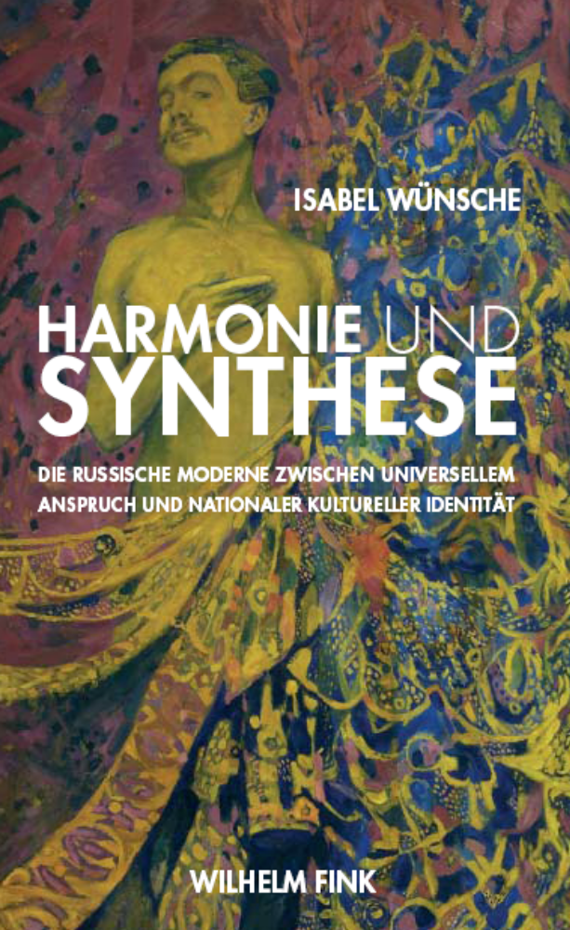
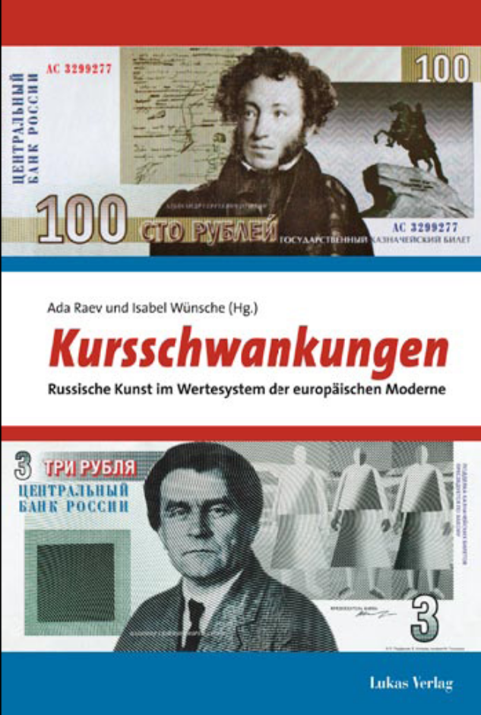
Funded Projects

- Research Fellowship
National Humanities Center, Research Triangle Park, North Carolina, USA, 2007-08
Book Project: "Mikhail Matiushin and the Organic School of the Russian Avant-Garde"
- Research Stay in Central and Eastern Europe/CIS
Deutsche Forschungsgemeinschaft
Archival Research in Moscow and St. Petersburg, 2007-08
- Research and Exhibition Grant
Nancy and Norton Dodge Collection of Nonconformist Art from the Soviet Union, New York, USA, 3-4/2007
Exhibition: "The Heritage of the Russian Avant-Garde: Vladimir Sterligov and His School," Jane Voorhees Zimmerli Museum of Art, Rutgers University, New Jersey

Organization of Scientific Conferences

April 2008
National Humanities Center, Research Triangle Park, North Carolina, USA
Art before and after Ideology
Funded by the National Humanities Center.
35 national (US), 10 international (non-US) participants.
Focusing on art and ideology in the twentieth century, the symposium investigated aspects such as radical ideologies in European modernism, the clash of aesthetic and political ideologies in revolutionary Russia, and the dismissal of ideology in most of the contemporary academic art historical narratives. Discussion centered on questions such as: How does the artist’s or writer’s ideological agenda change the environment around her/him? What does it take to make art ideological, and how dangerous is the aestheticization of politics? Can art actually exist outside of ideology?

Other Professional Activities

- Guest Curator of the exhibition "The Heritage of the Russian Avant-Garde: Vladimir Sterligov and his School", Nancy and Norton Dodge Collection of Nonconformist Art from the Soviet Union, Rutgers, The State University of New Jersey, New Brunswick, April 7 – October 14, 2007 (part 1), October 21-May 23, 2008 (part 2)

PhD-Students

Laura Petican
The persistence of the Baroque mentality in Arte Povera

Yuliya Salauyova
Walter Benjamin and new media: some methodological aspects

Research Personnel

Elina Knorpp
Research Associate
Conference and Research Project
until March 2007

Guests

Prof. Dr. Hans van Miegroet
Duke University, USA
October 2008

